**Entrepreneurs Vs. Managers**

The main difference between Entrepreneur and Manager is their role in the organization. An entrepreneur is the owner of the company whereas a Manager is the employee of the company. Entrepreneur is a risk taker; they take financial risk for their enterprise. The entrepreneur has a vision and focuses on achievements and profit.

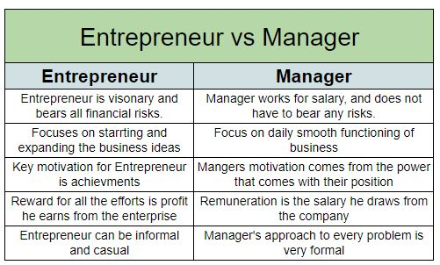

**Difference between Entrepreneur and Manager**

* The key **difference between an entrepreneur and a manager** is their standing in the company. An entrepreneur is a visionary that converts an idea into a business. He is the owner of the business, so he bears all the financial and other risks. A manager, on the other hand, is an employee, he works for a salary. So he does not have to bear any risks.
* The focus of an entrepreneur lies in starting the business and later expanding the business. A manager will focus on the daily smooth functioning of the business.
* For an entrepreneur the key motivation is achievements. But for the managers, the motivation comes from the power that comes with their position.
* The reward for all the efforts of an entrepreneur is the profit he earns from the enterprise. The manager is an employee, so his remuneration is the salary he draws from the company.
* The entrepreneur can be informal and casual in his role. However, a manager’s approach to every problem is very formal.
* The entrepreneur by nature is a risk taker. His has to take calculated risks to drive the company further. A manager, on the other hand, is risk-averse. His job is to maintain the status quo of the company. So he cannot afford risks.

**The manager takes scientific approaches, and his decisions are more calculative in nature. An entrepreneur has an informal approach and his decisions tend to be more intuitive in nature.**